SLW989 Giant Aurora Keyboard Playmat Manual
Before using the Giant Aurora Keyboard Playmat for the first time, kindly take time to carefully read the instructions. Please observe all safety precautions and follow operating procedures. After reading, kindly store the instructions in a safe place for your future reference. If you pass this Giant Aurora Keyboard Playmat to a third party, please include the instructions as well.

Giant Aurora Keyboard Playmat
Item # SLW989
This unit includes: 1 x Giant Aurora Keyboard Playmat and 1 x MP3 cable
Before use:
Open the back battery compartment with a screwdriver and install 4 AA batteries (not included).
Close the lid and flatten the mat.
Do not place the mat on an uneven surface as this may damage LED panels.
When the power is on, the mat will play a Power On Signal.

Tone
- The default instrument is piano.
- Instruments can be selected by pressing 'TONE' key.
- There are 8 instruments including piano, vibraphone, harp, trumpet, saxophone, accordion, violin and guitar.
- Press white keys to start playing desired instrument.
- The playmat can be plugged in any external music devices like iPhone and MP3 players to play favorite songs.

Learning
- Press ‘LEARNING’ to begin follow me function.
- Press black keys to change learning melody.
- Press ‘TONE’ to select desired instrument.
- Press any mode key to change to desired mode.

Demo
- When the ‘DEMO’ mode key is pressed, the system switches to melody demo play mode.
- The default instrument is piano and can be changed by pressing 'TONE'.
- Press black keys to change demo melody.
- The selected melody will be played in the selected instrument effect.
- The DEMO mode does not respond to white keys.
- DEMO function is not available while external music device is plugged in. Other functions remain the same.
- Press any mode key to change to desired mode.

Record
- When the ‘RECORD’ mode key is pressed, the record function will be activated.
- The instruments can be changed by pressing 'TONE'.
- Memory will be cleared by pressing 'RECORD' again.

Play Back
- Press ‘PLAYBACK’ to play back recorded melody.
- After all recorded notes have been played, pressing 'PLAYBACK' will replay the same melody again.

Product Photo
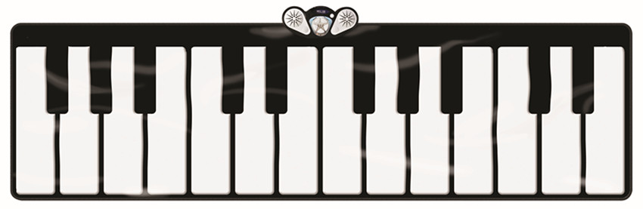

Battery Warning and Caution
• Replacement of batteries must be done by adults.
• Do not mix alkaline, standard or rechargeable batteries.
• Never mix old and new batteries.
• Batteries are to be inserted with the correct polarity.
• Exhausted batteries are to be removed from the toy.
• Rechargeable batteries are to be removed from the toy before being charged.
• Rechargeable batteries are only to be charged under adult supervision.
• Do not use any sharp items on the mat.
• The mat is not washable.
• This toy is for kids age 3 and up. Adult supervision is required.

