SLW9828 Music Style Playmat Manual
Before using the Music Style Playmat for the first time, kindly take time to carefully read the instructions. Please observe all safety precaution and follow operating procedures after reading, kindly store the instructions in a safe place for your future reference. If you pass this Music Style Playmat to a third party, please include the instructions as well.

Music Style Playmat
Item # SLW 9828
This unit includes: 1 x Music Style Playmat, 1 x microphone headset and 1 x MP3 cable

Before use:
Open the back battery compartment with a screwdriver and install 4 AA batteries (not Included). Close the lid and open the mat.
Turn the switch to ‘On’. You will hear a tone once the unit is turned on.
A microphone and/or MP3 player can be plugged into the outlet on the back of the music console. Microphone works under any mode. Only the drums and piano can be played when the MP3 player is plugged in.

Play:
- Once the unit is turned on, all instruments can be played.
- The ‘Tone’ button on top allows you to change the tone to 8 different instrument tones and can be heard when the piano keys are played. Each time you press a key, one note of the selected melody will play in the selected instrument effect: Piano, Saxophone, Trumpet, Vibraphone, Harp, Guitar, Music Box and Accordion.
- The ‘Demo’ button on top allows you to play 9 built in songs. The song changes every time the ‘Demo’ button is pressed. All instruments can be played while the demo song is playing.
- The 8 rhythm buttons on the top right provide different sound effects and all instruments can be played while the rhythm music is playing.
- 2 different sound effects are available by turning the record on the music console.

Product Photo
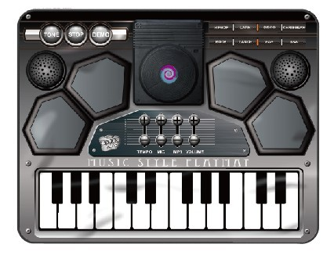

Battery Warning and Caution
• Replacement of batteries must be done by adults.
• Do not mix alkaline, standard or rechargeable batteries.
• Never mix old and new batteries.
• Batteries are to be inserted with the correct polarity.
• Exhausted batteries are to be removed from the toy.
• Rechargeable batteries are to be removed from the toy before being charged.
• Rechargeable batteries are only to be charged under adult supervision.
• Do not use any sharp items on the mat.
• The mat is not washable.
• This toy is for kids age 3 and up. Adult supervision is required.

