SLW9826 Move and Groove Playmat Manual
Before using the Move and Groove Playmat for the first time, kindly take time to carefully read the instructions. Please observe all safety precautions and follow operating procedures. After reading, kindly store the instructions in a safe place for your future reference. If you pass this Move and Groove Playmat to a third party, please include the instructions as well.

Move and Groove Playmat
Item # SLW9826
This unit includes: 1 x Move and Groove Playmat and 1x built-in control box with flashing LED laser light.
Before use:
Open the back battery compartment with a screwdriver and install 4 AA batteries (not included). Close the lid and flatten the mat. When the power is on, the mat will play a Power On Signal.

Play
• Mode 1 is the default mode once it is switched on. Press ‘MODE’ to select one of the two modes.
• Mode 1 is free dancing mode. Kids step on flashing buttons and dance to the music.
• Mode 2 is dancing challenge mode. Kids have to step on the flashing buttons correctly more than 7 times to pass the game.
• Press ‘+’ and ‘-‘ to adjust the speed of music and light.
• Press ‘SELECT’ to choose background music from the built-in 5 songs.
•MP3 function: When MP3 player is plugged in, the built-in music is not available to play. The speaker will play music from MP3 player and lights will flash according to the playing music.
• Volume is adjustable on control box.

Product Photo
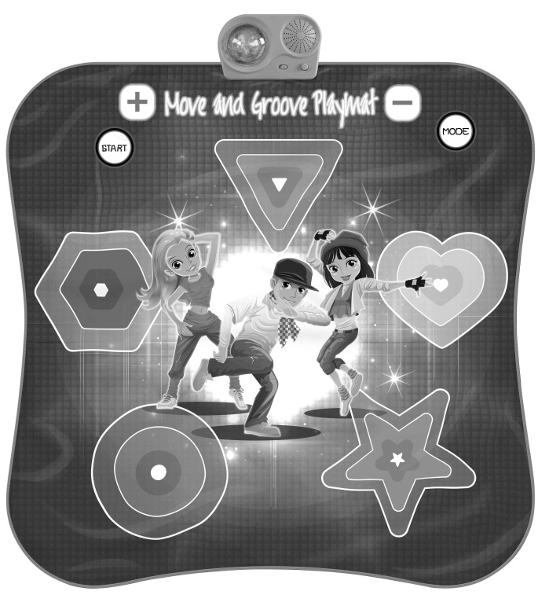

Battery Warning and Caution
• Replacement of batteries must be done by adults.
• Do not mix alkaline, standard or rechargeable batteries.
• Never mix old and new batteries.
• Batteries are to be inserted with the correct polarity.
• Exhausted batteries are to be removed from the toy.
• Rechargeable batteries are to be removed from the toy before being charged.
• Rechargeable batteries are only to be charged under adult supervision.
• Do not use any sharp items on the mat.
• The mat is not washable.
• This toy is for kids age 3 and up. Adult supervision is required.

