SLW9823 iDrumz Playmat Manual
Before using the iDrumz Playmat for the first time, kindly take time to carefully read the instructions. Please observe all safety precautions and follow operating procedures. After reading, kindly store the instructions in a safe place for your future reference. If you pass this iDrumz Playmat to a third party, please include the instructions as well.

iDrumz Playmat
Item # SLW9823
This unit includes: 1 x iDrumz Playmat, 2 x drumstick and 1 x MP3 cable
Before use:
Open the back battery compartment with a screwdriver and install 4 AA batteries (not included). Close the lid and flatten the mat. When the power is on, the mat will play a Power On Signal.
Play
- The default mode is free mode when power is on. Start playing music by hitting the musical instruments with drumsticks.
- Plug in external music device to play favorite tunes. Hitting instruments on the playmat to play along with background music.
- Press “VOLUME+” and “VOLUME-“to adjust volume.
Product Photo
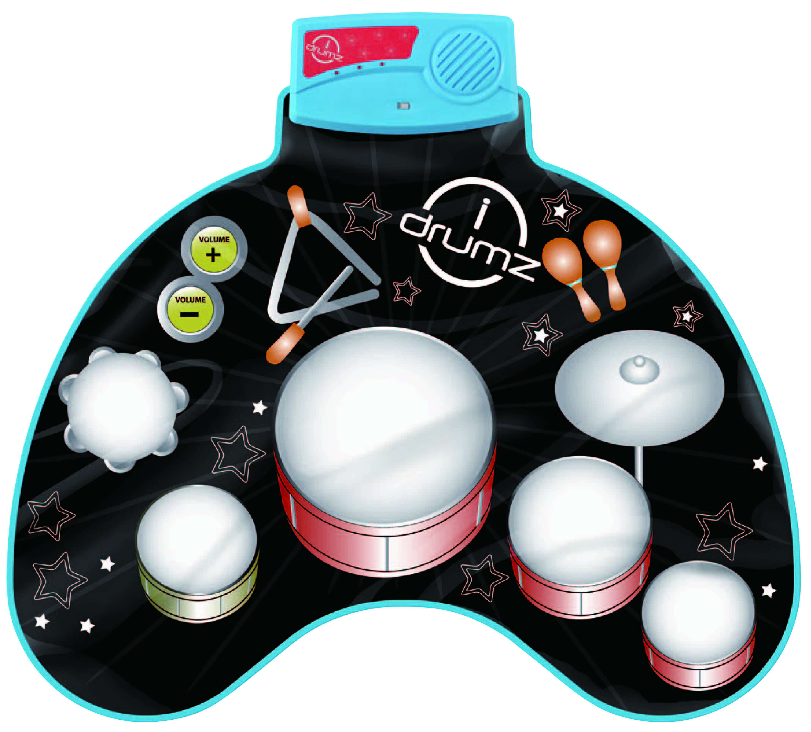
Battery Warning and Caution
• Replacement of batteries must be done by adults.
• Do not mix alkaline, standard or rechargeable batteries.
• Never mix old and new batteries.
• Batteries are to be inserted with the correct polarity.
• Exhausted batteries are to be removed from the toy.
• Rechargeable batteries are to be removed from the toy before being charged.
• Rechargeable batteries are only to be charged under adult supervision.
• Do not use any sharp items on the mat.
• The mat is not washable.
• This toy is for kids age 3 and up. Adult supervision is required.

