SLW9822 Happy Alarm Playmat Manual
Before using the Happy Alarm Playmat for the first time, kindly take time to carefully read the instructions. Please observe all safety precautions and follow operating procedures. After reading, kindly store the instructions in a safe place for your future reference. If you pass this Happy Alarm Playmat to a third party, please include the instructions as well.

Happy Alarm Playmat
Item # SLW9822
This unit includes: 1 x Happy Alarm Playmat with control box
Before use:
Open the back battery compartment with a screwdriver and install 3 AA batteries (not included). Close the lid and flatten the mat.
When the power is on, the mat will play a Power On Signal.

Play
• Time setting: press ‘TIME’, adjust hour by pressing ‘SET’; Press ‘SEL’ to move onto minute and adjust minute number through button ‘SET’; press ‘TIME’ again to complete time setting.
• Alarm setting: press ‘ALM’, adjust hour by pressing ‘SET’; button ‘SEL’ for switching between hour and minute; adjust minute through button ‘SET’; press ‘ALM’ again to complete alarm setting.
• Play mode: it is game mode when you switch to ‘PLAY’. Press ‘START’ to begin the game; there are 3 levels in this game mode. Level 1: only one LED light flashes a time, player can only have 5 chances within 1 minute; Level 2: only one LED light flashes a time, time intervals between flashes are shorter; Level 3: one or two lights shown at this level, player has to get the correct lights simultaneously when two lights are displayed.
• No alarm function when Play mode is activated.
• No button is available on the playmat when alarm is activated. When the alarm goes off, player has to step any buttons 30 times in order to stop the alarm. Otherwise the alarm will never stop which is a great help to parents for waking up kids in the morning.
• “+” and “-“ for volume control.

Product Photo

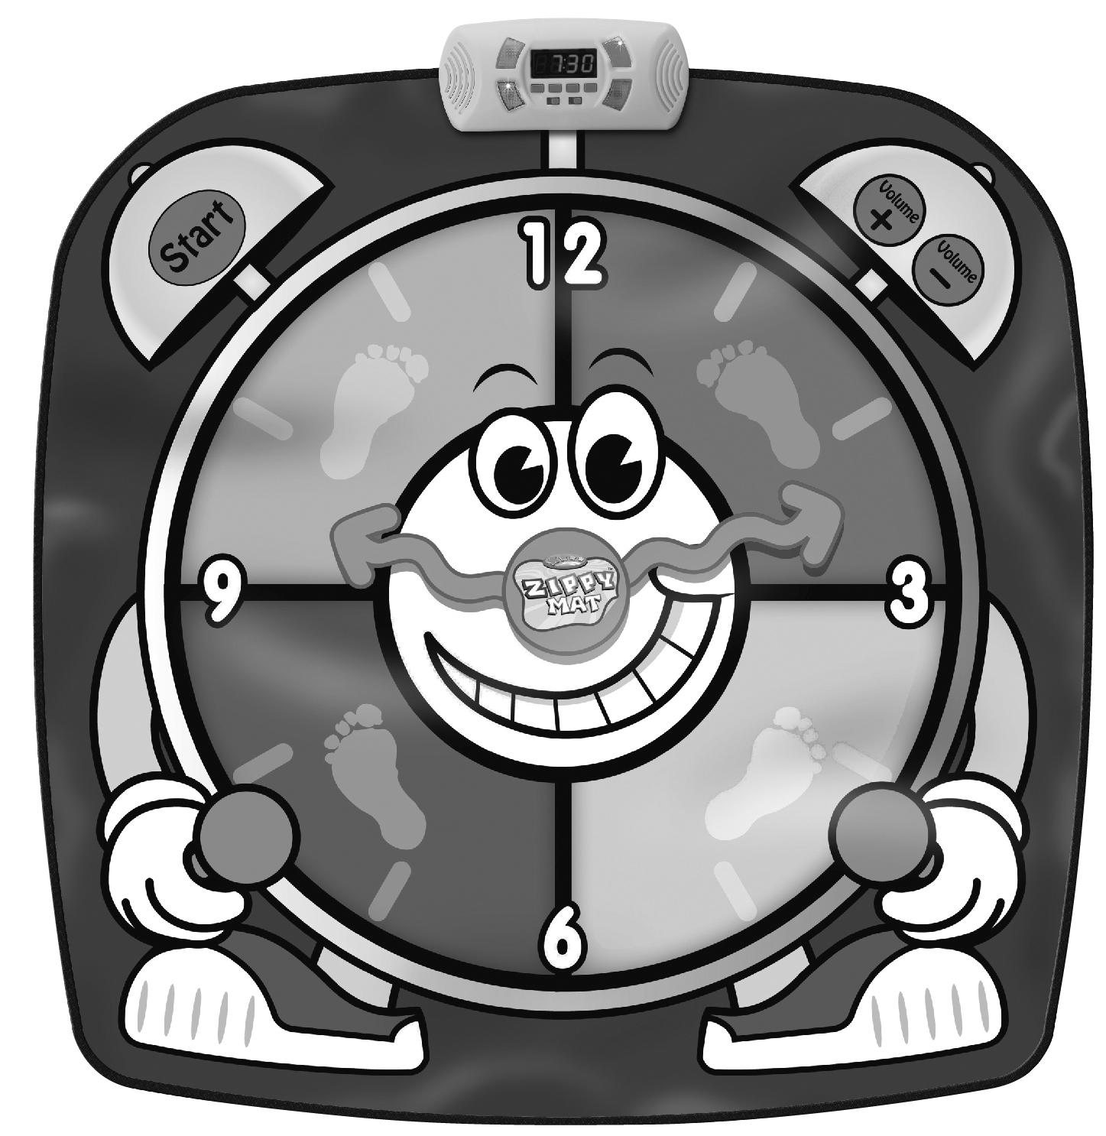
Battery Warning and Caution
• Replacement of batteries must be done by adults.
• Do not mix alkaline, standard or rechargeable batteries.
• Never mix old and new batteries.
• Batteries are to be inserted with the correct polarity.
• Exhausted batteries are to be removed from the toy.
• Rechargeable batteries are to be removed from the toy before being charged.
• Rechargeable batteries are only to be charged under adult supervision.
• Do not use any sharp items on the mat.
• The mat is not washable.
• This toy is for kids age 3 and up. Adult supervision is required.

