SLW9723 Percussion Mixer Playmat Manual
Before using the PERCUSSION MIXER PLAYMAT for the first time, kindly take time to carefully read the instructions. Please observe all safety precautions and follow operating procedures. After reading, kindly store the instructions in a safe place for your future reference. If you pass this PERCUSSION MIXER PLAYMAT to a third party, please include the instructions as well.

Percussion Mixer Playmat
Item # SLW9723
This unit includes: 1 x Percussion Mixer Playamt and 1 x MP3 cable
Before use:
Open the back battery compartment with a screwdriver and install 4 AA batteries (not included). Close the lid and flatten the mat. When the power is on, the mat will play a Power On Signal.
Play
- Mode 1: when the power is on, the mat will play a Power On Signal, and player will see the indicating light “Mode 1” flashing. Mode 1 is a free mode. Player will hear the correspondent instrument sound by pressing any of musical instruments.
- Mode 2: press “Start” key to enter “Mode 2” and indicating light will be flashing. With background music, player can press any of the instruments to compose music. Player can also change background music by pressing “Select” key.
- Plug in MP3 player to play favorite tunes. When MP3 player is plugged in, the playmat will be turned to Mode 1 automatically and Mode 2 will not be available.
Product Photo
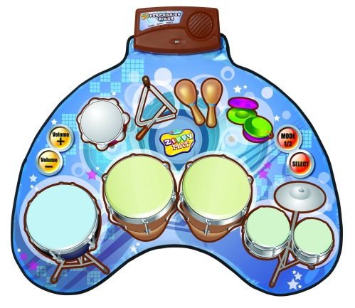
Battery Warning and Caution
• Replacement of batteries must be done by adults.
• Do not mix alkaline, standard or rechargeable batteries.
• Never mix old and new batteries.
• Batteries are to be inserted with the correct polarity.
• Exhausted batteries are to be removed from the toy.
• Rechargeable batteries are to be removed from the toy before being charged.
• Rechargeable batteries are only to be charged under adult supervision.
• Do not use any sharp items on the mat.
• The mat is not washable.
• This toy is for kids age 3 and up. Adult supervision is required.

