SLW968 Gigantic Keyboard Playmat Manual

Before using the Gigantic Keyboard Playmat for the first time, kindly take time to carefully read the instructions. Please observe all safety precautions and follow operating procedures. After reading, kindly store the instructions in a safe place for your future reference. If you pass this Gigantic Keyboard Playmat to a third party, please include the instructions as well.

Gigantic Keyboard Playmat
Item # SLW 968
This unit includes: 1 x Gigantic Keyboard Playmat with control box
Before use:
Open the back battery compartment with a screwdriver and install 4 AA batteries (not included). Close the lid and flatten the mat. When the power is on, the mat will play a Power On Signal.

Play
- When the Play mode key is pressed, the system switches to one key play mode. The default instrument is the piano.
- Any instrument can be selected by pressing the desired instrument key.
- There are 8 instruments: Piano, Vibraphone, Oboe, Trumpet, Saxophone, Banjo, Violin, and Guitar.
- The selected melody can be played in the selected instrument effect by pressing a white key to start.
- Each time you press a key, one note of the selected melody will play in the selected instrument effect.
- Selected melody and selected instrument can be changed any time by pressing the desired melody key and desired instrument key.
- Press any mode key to change the music to that desired mode immediately.

Demo
- When the Demo mode key is pressed, the system switches to melody demo play mode.
- The default instrument is the piano and can be changed by pressing any other instrument key at any time.
- Press black keys to change demo melody.
- The Demo mode does not respond to the white keys.
- When one melody is playing, the player can select and play another melody by pressing the desired melody key.
- Press any mode key to change to desired mode.

Record
- When the Record mode key is pressed, the record function will be activated.
- The instruments can be changed by pressing any other instrument key at any time.
- Memory will be cleared by pressing the record mode key again.

Play Back
- Press ‘Playback’ to play back the recorded song.
- After all recorded notes have been played, pressing the Playback key will replay the same songs again.

Product Photo
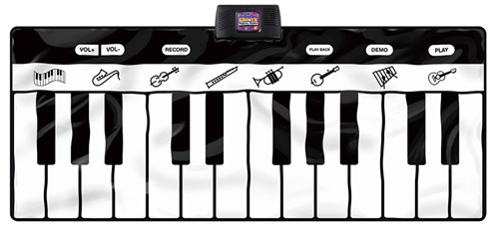

Battery Warning and Caution
• Replacement of batteries must be done by adults.
• Do not mix alkaline, standard or rechargeable batteries.
• Never mix old and new batteries.
• Batteries are to be inserted with the correct polarity.
• Exhausted batteries are to be removed from the toy.
• Rechargeable batteries are to be removed from the toy before being charged.
• Rechargeable batteries are only to be charged under adult supervision.
• Do not use any sharp items on the mat.
• The mat is not washable.
• This toy is for kids age 3 and up. Adult supervision is required.

