SLW939 Animals’ Carnival Playmat Manual
Before using the Animals’ Carnival Playmat for the first time, kindly take time to carefully read the instructions. Please observe all safety precautions and follow operating procedures. After reading, kindly store the instructions in a safe place for your future reference. If you pass this Animals’ Carnival Playmat to a third party, please include the instructions as well.

Animals’ Carnival Playmat
Item # SLW939
This unit includes: 1 x Animals’ Carnival Playmat with control box
Before use:
Open the back battery compartment with a screwdriver and install 3 AA batteries (not included). Close the lid and flatten the mat. When the power is on, the mat will play a Power On Signal.

Play
- 3 modes to select: demo, play and learning.
- 10 keys with LED lights
- ‘Play’ mode: This is free mode in which player can play keyboard in free style on the playmat with LED lights shown up.
- ‘Demo’ mode: Press ‘Demo’ to enter and select white keys to change demo songs. Each white key has one built-in demo song and the LED lights will flash. There are 10 demo songs to select.
- ‘Learning’ mode: Learn how to play a song by following lights on the playmat and it will become a complete melody. There are 10 songs for learning.
- Volume and tempo are adjustable.

Product Photo
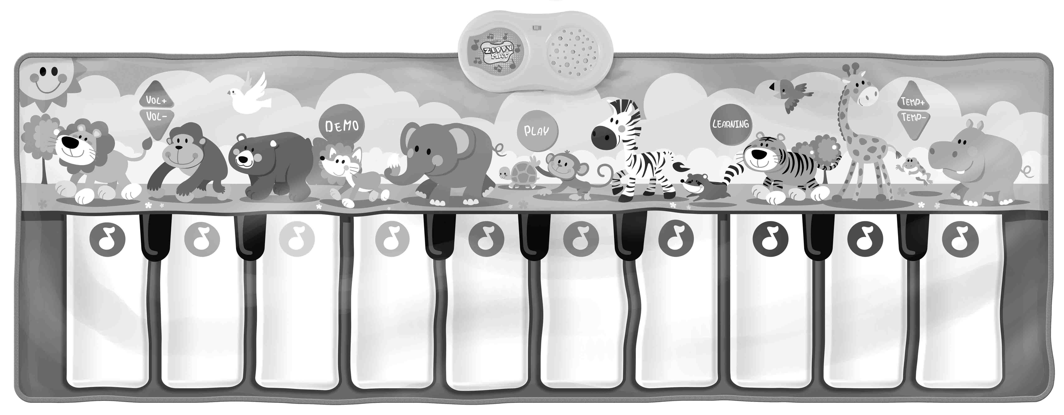
Battery Warning and Caution
• Replacement of batteries must be done by adults.
• Do not mix alkaline, standard or rechargeable batteries.
• Never mix old and new batteries.
• Batteries are to be inserted with the correct polarity.
• Exhausted batteries are to be removed from the toy.
• Rechargeable batteries are to be removed from the toy before being charged.
• Rechargeable batteries are only to be charged under adult supervision.
• Do not use any sharp items on the mat.
• The mat is not washable.
• This toy is for kids age 3 and up. Adult supervision is required.

