SLW9383 Mini Drum Kit Playmat Manual
Before using the Mini Drum Kit Playmat for the first time, kindly take time to carefully read the instructions. Please observe all safety precautions and follow operating procedures. After reading, kindly store the instructions in a safe place for your future reference. If you pass this Mini Drum Kit Playmat to a third party, please include the instructions as well.
Mini Drum Kit Playmat
Item # SLW9383
This unit includes: 1 x Mini Drum Kit Playmat and 2 x drumstick
Before use:
Open the back battery compartment with a screwdriver and install 2 AA batteries (not included). Close the lid and flatten the mat. When the power is on, the mat will play a Power On Signal.
Instructions
- 8 instrument beating areas.
- 2 modes to select.
- Adjustable volume.
- Press “DEMO” to play built-in demo songs
- Press “STOP” to stop all functions.
- Touch sensitive playmat.
Product Photo
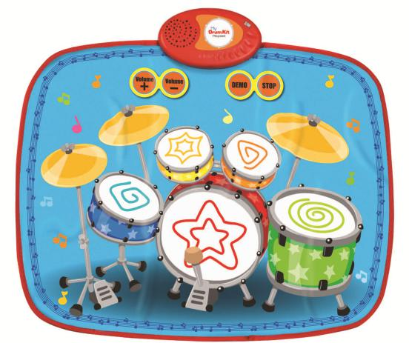
Battery Warning and Caution
• Replacement of batteries must be done by adults.
• Do not mix alkaline, standard or rechargeable batteries.
• Never mix old and new batteries.
• Batteries are to be inserted with the correct polarity.
• Exhausted batteries are to be removed from the toy.
• Rechargeable batteries are to be removed from the toy before being charged.
• Rechargeable batteries are only to be charged under adult supervision.
• Do not use any sharp items on the mat.
• The mat is not washable.
• This toy is for kids age 3 and above. Adult supervision is required.

