SLW9381 Rainbow Piano Playmat Manual
Before using the Rainbow Piano Playmat for the first time, kindly take time to carefully read the instructions. Please observe all safety precautions and follow operating procedures. After reading, kindly store the instructions in a safe place for your future reference. If you pass this Rainbow Piano Playmat to a third party, please include the instructions as well.
Rainbow Piano Playmat
Item # SLW9381
This unit includes: 1 x Rainbow Piano Playmat.
Before use:
Open the back battery compartment with a screwdriver and install 2 AA batteries (not included). Close the lid and flatten the mat. When the power is on, the mat will play a Power On Signal.
Instructions
- Default mode is piano mode, in which kids play the keyboard.
- Press 'PIANO' switch to demo mode, in which kids can select one of 8 demo songs by pressing 8 white keys on keyboard.
- Press 'PIANO' again and go back to piano mode.
- Press 'MEMORY' switch to follow me memory game, in which kids will hear a short clip of music from console box and after clip is finished, kids have to follow the same pattern and press corresponding keys on keyboard to complete the game. The difficulty will gradually increase.
- Press 'PIANO' again and go back to piano mode.
Product Photo
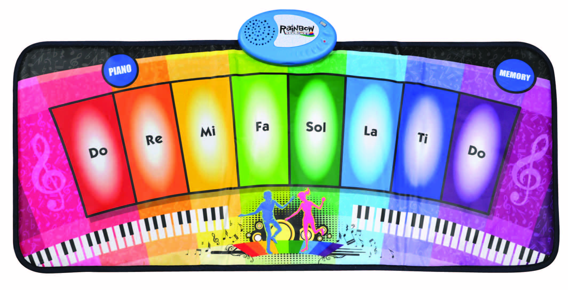
Battery Warning and Caution
• Replacement of batteries must be done by adults.
• Do not mix alkaline, standard or rechargeable batteries.
• Never mix old and new batteries.
• Batteries are to be inserted with the correct polarity.
• Exhausted batteries are to be removed from the toy.
• Rechargeable batteries are to be removed from the toy before being charged.
• Rechargeable batteries are only to be charged under adult supervision.
• Do not use any sharp items on the mat.
• The mat is not washable.
• This toy is for kids age 3 and above. Adult supervision is required.

