SLW920 Kick and Touch Piano Mat Manual
Before using the Kick and Touch Piano Mat for the first time, kindly take time to carefully read the instructions. Please observe all safety precautions and follow operating procedures. After reading, kindly store the instructions in a safe place for your future reference. If you pass this Kick and Touch Piano Mat to a third party, please include the instructions as well.

Kick and Touch Piano Mat
Item # SLW920
This unit includes: 1 xKick and Touch Piano Mat with control box
Before use:
Open the back battery compartment with a screwdriver and install 3 AA batteries (not included). Close the lid and flatten the mat. Hang the Kick and Touch Piano Mat on baby’s bed with straps.When the power is on, the mat will play a Power On Signal.

Play
- First mode: switch to right. It enters keyboard mode. Press 5 flowers to play the keyboard.
- Second mode: switch to middle. It enters short demo mode. Press one of the 5 flowers to select a short demo song to play.
- Third mode: switch to left. It enters long demo mode. Press one of the 5 flowers to select a long demo song to play.
- Volume adjustable.

Product Photo
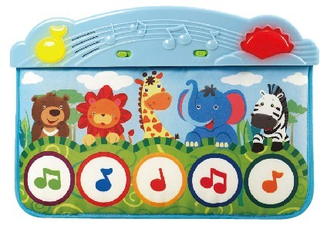
Battery Warning and Caution
• Replacement of batteries must be done by adults.
• Do not mix alkaline, standard or rechargeable batteries.
• Never mix old and new batteries.
• Batteries are to be inserted with the correct polarity.
• Exhausted batteries are to be removed from the toy.
• Rechargeable batteries are to be removed from the toy before being charged.
• Rechargeable batteries are only to be charged under adult supervision.
• Do not use any sharp items on the mat.
• The mat is not washable.
• This toy is for kids age0 and up. Adult supervision is required.

