SLW803 Goal Set Playmat Manual

Before using the Goal Set Playmat for the first time, kindly take time to carefully read the instructions. Please observe all safety precautions and follow operating procedures. After reading, kindly store the instructions in a safe place for your future reference. If you pass this Goal Set Playmat to a third party, please include the instructions as well.

Goal Set Playmat
Item # SLW803
This unit includes: 1 x Goal Set Playmat and 1 x Remote Control Panel.

Batteries Installation
Open the battery compartment on the back side of Goal Set Playmat with a screwdriver and install 3 AAA batteries (not included). Close the lid and switch to “ON” with red LED light indicated.
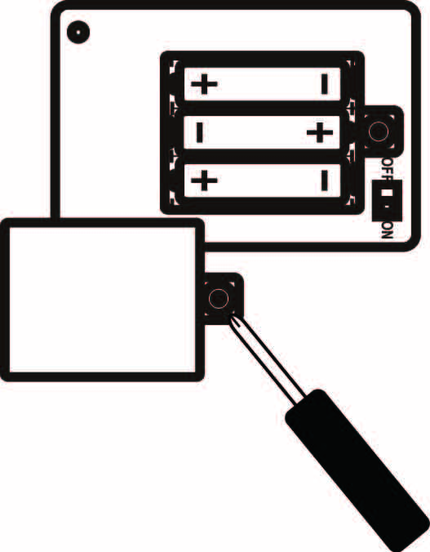
Open the back battery compartment on remote control panel with a screwdriver and install 4 AA batteries (not included). Close the lid and switch to “ON” with a power on signal.
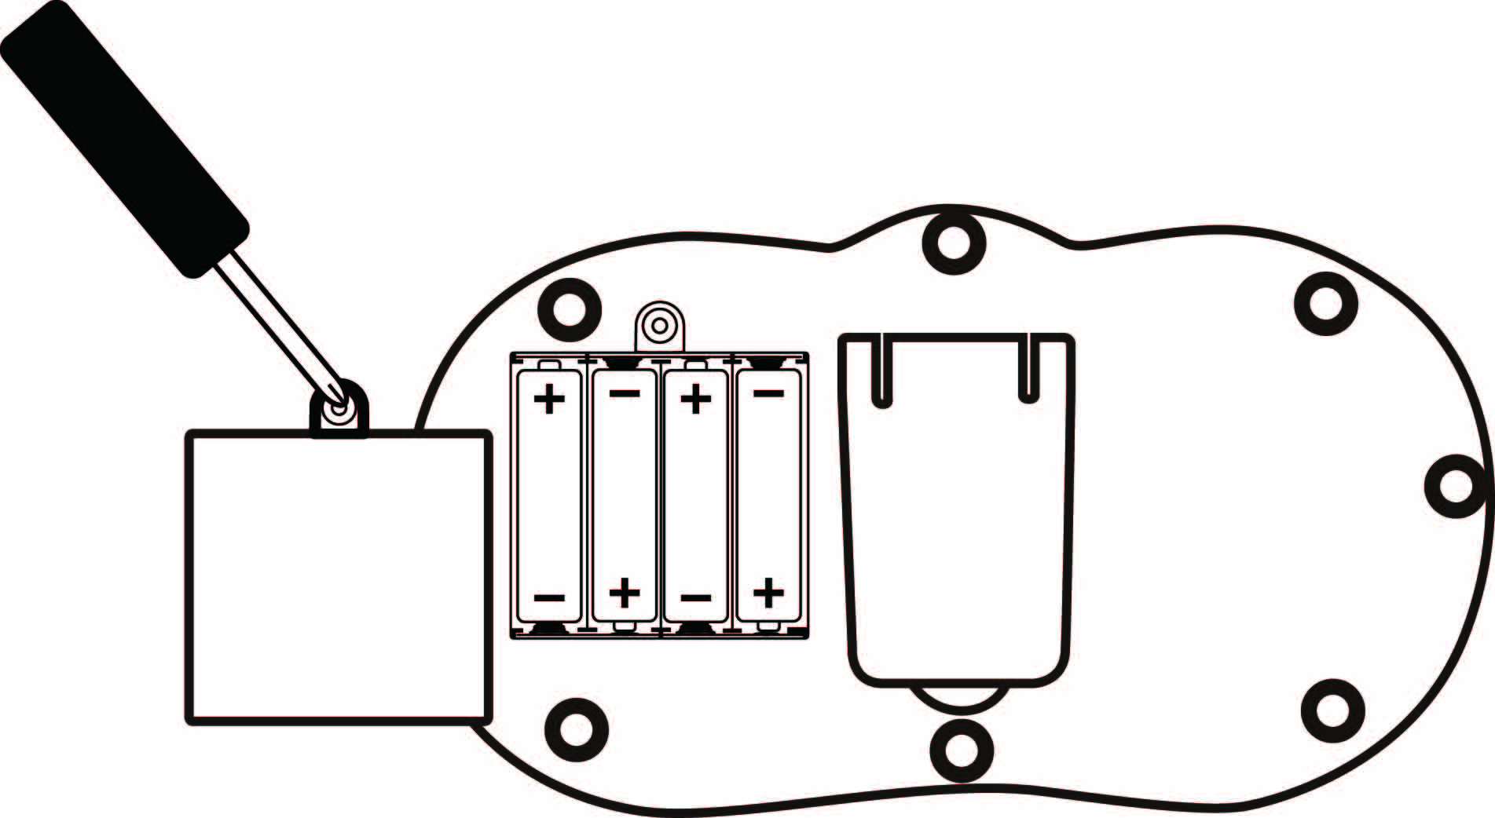
Play
Hang Goal Set Playmat on the wall with screws or hooks.
- 2 modes: practice mode and game mode
- Practice mode: Shoot football towards the mat and scores will be shown and recorded on control panel with scored number flashing.
- Game mode: player has to follow flashing number on control panel and shoot correct number on the mat. There are 30 seconds countdown for each game.

Product Photo
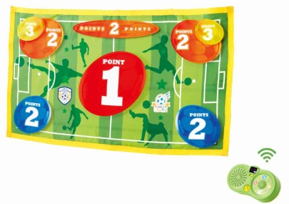

Battery Warning and Caution
• Replacement of batteries must be done by adults.
• Do not mix alkaline, standard or rechargeable batteries.
• Never mix old and new batteries.
• Batteries are to be inserted with the correct polarity.
• Exhausted batteries are to be removed from the toy.
• Rechargeable batteries are to be removed from the toy before being charged.
• Rechargeable batteries are only to be charged under adult supervision.
• Do not use any sharp items on the mat.
• The mat is not washable.
• This toy is for kids age 3 and up. Adult supervision is required.

