Mini Dancing Trampoline
Instruction Manual
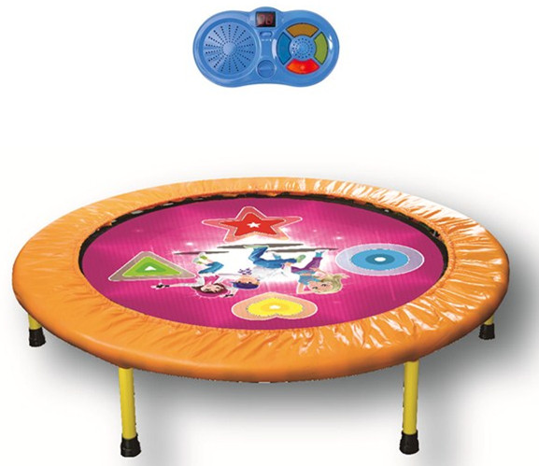
- WARNING
- ADULT ASSEMBLY REQUIRED
- FOR USE BY THOSE 6+ YEARS OF AGE AND ABOVE
- WEIGHT LIMIT 100KGS
- SAFE USE REQUIRES NO MORE THAN 1 USER AT A TIME
- READ THESE MATERIALS PRIOR TO ASSEMBLING AND USING THIS TRAMPOLINE
LIABILITY
While every attempt is made to embody the highest degree of protection in all equipment, we cannot guarantee freedom from injury. The user assumes all risk of injury due to use. All merchandise is sold on this condition, which no representative of the company can waive or change.

ESSENTIAL INFORMATION
- Misuse and abuse of this trampoline is dangerous and can cause serious injuries.
- Trampolines, being rebounding devices, propel the performer to unaccustomed heights and into a variety of body movements.
- All purchasers or persons assembling and using the trampoline must become familiar with the manufacturer’s recommendations for the proper assembly, use, and care of the trampoline. Also, be alert to the user’s limitations in the execution of trampoline techniques and progressions. Suggestions for the care and maintenance are included to promote safe, enjoyable use of this product.
- It is the responsibility of the owner to insure that all users of this trampoline are adequately informed of all warnings and safety instructions.
- Always check with your doctor before starting any exercise program.
- This item has small parts, not for children under 6 years old.
- Adult assembly required. Care should be taken in the unpacking & assembly of the trampoline.
NOT FOR PROFESSIONAL USE.
WEIGHT LIMIT FOR TRAMPOLINE USER IS 100KGS.

INSTALLATION INSTRUCTIONS
- Adequate overhead clearance is essential. A minimum of 10ft from ground level is recommended. Provide clearance for wires, ceiling fans, and other possible hazards.
- Lateral clearance is essential. Place the trampoline away from walls, structures, furniture, and other play areas. Maintain a clear space on all sides of the trampoline. A minimum of 6 ft from frame edge is recommended.
- The trampoline is under heavy tension. Three able-bodies adults are required to set it up. Use appropriate clothing and shoes. Failure to follow these instructions may lead to injury or damage to the trampoline.
- Place the trampoline on a level surface before use.
- Use the trampoline in a well-lighted area. Artificial illumination may be required.
- Remove any obstructions from beneath the trampoline.
- The owner and supervisors of the trampoline are responsible to make all users aware of practices specified in the use instructions.

CARE AND MAINTENANCE INSTRUCTIONS
Inspect the trampoline before each use and replace any worn, defective, or missing parts.
The following conditions could represent potential hazards:
- Missing, improperly positioned or insecurely attached frame padding.
- Punctures, frays, tears or holes worn in the bed or frame padding.
- Deterioration in the stitching or fabric of the bed or frame padding.
- Ruptured band.
- A bent or broken frame.
- A sagging bed.
- Sharp protrusions on the frame or suspension system.
- Loosened or missing legs.

For extra protection, periodically apply a silicon spray on stretch-bandstraps to prevent deterioration.

USE INSTRUCTIONS
- Do not allow more than one person on the trampoline. Use by more than one person at the same time can result in serious injuries.
- Keep objects away which could interfere with the performer. Maintain a clear area around the trampoline. Do not allow foreign objects or animals on the trampoline.
- Use trampoline only with mature, knowledgeable supervision.
- The trampoline should be assembled in its entirely before each use. The frame cover should be positioned correctly at all times. By doing this you will prolong the life of the bands by shielding it from the elements and at the same time make the trampoline safer.
- Inspect the trampoline before each use. Make sure the frame cover is correctly and securely positioned. Replace any worn, defective, or missing parts.
- The metal frame of the trampoline will conduct electricity. Lights, extension cords, and all such electrical equipment must never be allowed to come in contact with the trampoline.
- Wear comfortable clothing. Remove jewelry, necklaces, and earrings.
- Step on and off the trampoline. It is a dangerous practice to jump from the trampoline to the ground or floor when dismounting, or to jump onto the trampoline when mounting. Do not use the trampoline as a springboard to other objects.
- Stop bounce by flexing knees as feet come in contact with the trampoline bed. Learn this skills before attempting others.
- Avoid bouncing too high. Stay low until bounce control and repeated landing in the center of the trampoline can be accomplished. Control is more important than height.
- While keeping the head erect, focus eyes on the trampoline toward the perimeter. This will help control bounce.
- Avoid bouncing when tired. Keep turns short.
- Do not use the trampoline while under the influence of alcohol or drugs.
- For additional information concerning the trampoline equipment, contact the manufacturer.
- Bounce only when the surface of the bed is dry.
- Read all instructions before using the trampoline. Warnings and instructions for the care, maintenance, and use of this trampoline are included to promote safe, enjoyable use of this equipment.
- Once the circular steel frame is assembled, it may not be taken apart.
- Do not fold the mat frequently and store flat to prevent circuit breaks
- Colors and contents may vary from illustration.
- Packing has to be kept since it contains important information.
- Do not use close to the ear! Misuse may cause damage to hearing.

TRAMPOLINE SAFETY AND ACCIDENT PREVENTION
As in most recreational sport, participants may be injured. This section covers the most common accidents. Responsibilities of the supervisors and jumpers in accident prevention are also outlined. The following are reasons why accidents happen:
- Attempting somersaults. Landing on the head or neck can cause serious injury, paralysis, or death, even when landing in the middle of the bed.
- More than one person on the trampoline. Use by more than one person at the same time can result in serious injuries.
- Incorrect mounting and dismounting. Carefully step out of and onto the trampoline bed. Do not jump off to the ground. Do not jump from a table, or other object onto the ground. Do not step onto the suspension system.
- Hitting the frame. A jumper who loses control will increase his/her change of injury. To regain control and stop your jump, bend your knees sharply as you land.
- Alcohol and drug use. Because alcohol and drug use impairs the jumper’s coordination, loss of control as well as injuries is greatly increased.
- Foreign objects. Please make sure there is nothing sharp under and around the trampoline. Hitting objects under the trampoline can cause injury. Jumping with a foreign object can also increase the chances of getting injured. Be sure there is adequate clearance 10 feet above and 10 feet around the trampoline. Be careful of overhead wires, ceiling fans etc.
- Poor maintenance of the trampoline. Make sure you inspect the trampoline before every use. Check for punctures on the bed, sharp burrs on the frame, stitching that has gone bad or loose elastic bands.
- Storage. Once the circular frame is assembled, it may not be taken apart. Remove legs & store entire frame when not in use.

ASSEMBLY INSTRUCTIONS
Place all parts from the box in a cleared area and position them on the floor in front of you. Remove all packing materials from you area and place them back into the box. Do not dispose of the packing materials until assembly is completed. Read each step carefully before beginning.

WARNING: 1 adult in good physical condition are required for the following assembly. Wear proper shoes and maintain balance to prevent a fall. Failure to follow all instructions and warnings exactly may result in serious injury.

- Keep children away from the trampoline during assembly.
- Keep finger away from the ends of the rails in the hinge area when unfolding the trampoline. the trampoline will snap into the unfold position. Serious injury can occur if fingers are caught between the ends of the rails.
- When unfolding the trampoline, the rails will try to spring back to the folded position if they are released before they snap into place.
- The safety cover must be installed before using the trampoline.

ASSEMBLY
Part 1: Trampoline
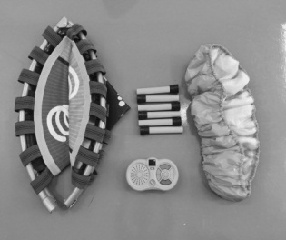
- Lay all the parts down.
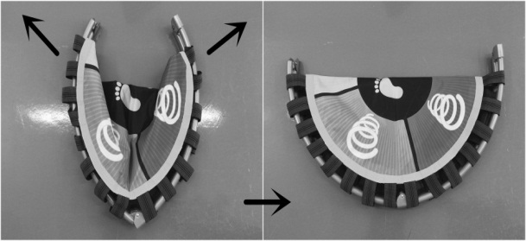
- Unfold the frame as shown and be careful not to pinch your fingers.
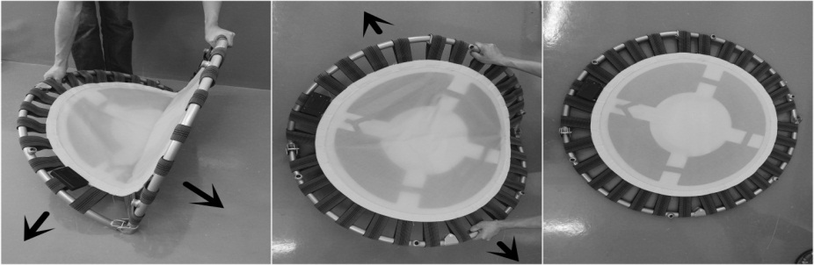
- Slowly open the two half circles and continue opening the circle until the joints lock together. Please be careful that there is a lot of tension here and servere injury may occur if these instructions are not followed. Take extra precaution in avoiding any pinch points.Inspect the frame and make sure it is straight and round. Even out all the bands.
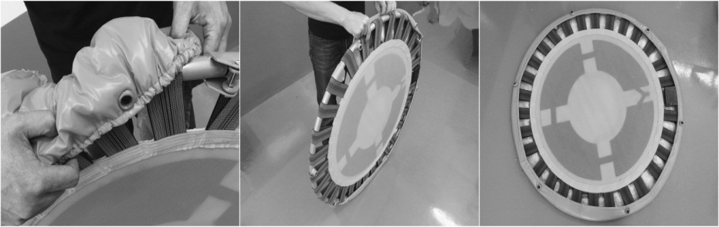
- After the frame has locked into place, remove the plastic caps from the threaded sockets and insert the frame cover through the first socket.
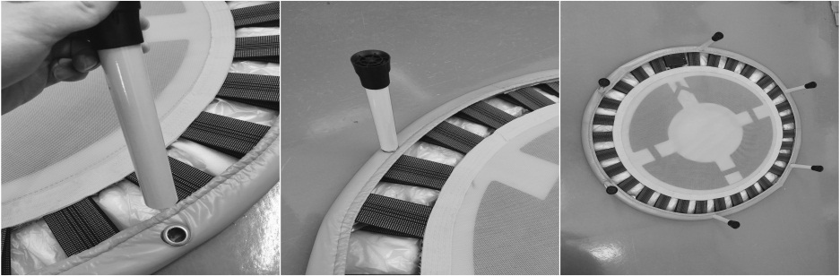
- Screw the 6 legs on and straighten the cover making sure it is evenly covering the suspension system.
Part 2: Control Panel
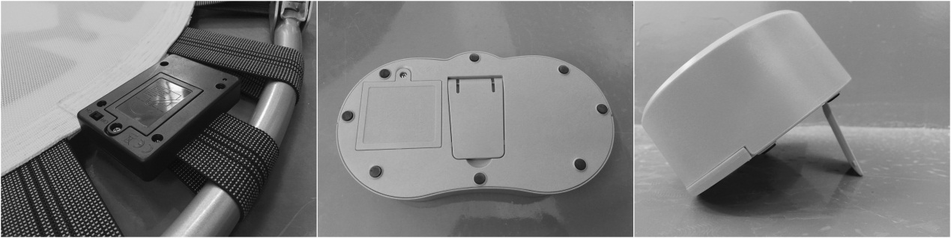
- Install 3* “AAA” size batteries to battery compartment on the back side of trampoline. Install 4* “AA” size batteries to battery compartment on the back side of control panel. Open the stand and place the control panel at a visible position. Refer to BATTERIES INSTALLATION for correct operation.
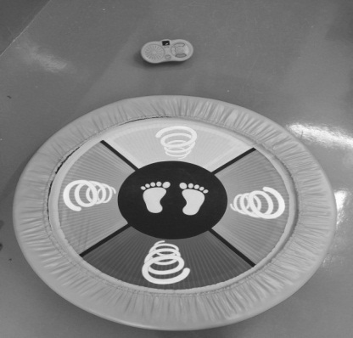
- Congratulations and have fun with your dancing trampoline.
BATTERIES INSTALLATION
- Open the battery compartment on the back side of trampoline with a screwdriver and install 3 AAA batteries (not included). Close the lid, turn the switch to “ON” with red LED light indicated. Flip over the trampoline to correct position.
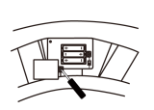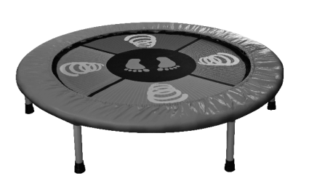
- Open the back battery compartment on control panel with a screwdriver and install 4 AA batteries (not included). Close the lid and switch to “ON”, it will play a power on signal.
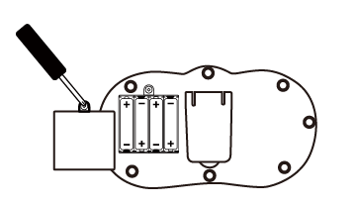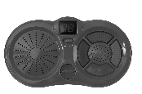

HOW TO PLAY
- Place the control panel wherever you like as long as it is visible while you are dancing on the trampoline.
- Switch to “ON”. This is the default dancing mode that kids follow the indication lights on control panel and jump on corresponding pattern(s) of the trampoline to get a score. The score will be accumulated and displayed once correct pattern(s) is hit.
- Plug in external music device to play favorite tunes and dance along. The background music will be stopped once it is plugged. The dancing game function remains the same.
- The frequency range between trampoline and control panel is 2.4GHz and the operation range is 10 meters.

BATTERY WARNING AND CAUTION
- Replacement of batteries must be done by adults.
- Do not mix alkaline, standard or rechargeable batteries.
- Never mix old and new batteries.
- Batteries are to be inserted with the correct polarity.
- Exhausted batteries are to be removed from the toy.
- Rechargeable batteries are to be removed from the toy before being charged.
- Rechargeable batteries are only to be charged under adult supervision.
- Do not use any sharp items on the mat.
- The mat is not washable.
- This toy is for kids age 6 and up. Adult supervision is required.

